SQL Query Assignment 1

Premiere Products

## Setup The Database

* Create a new database called premiere
* Acquire the premiere.sql file from Blackboard
* Create a new query - ensure that the right database is selected
* Paste the code into the new query
* Execute the premiere.sql code

## Look at the relationships

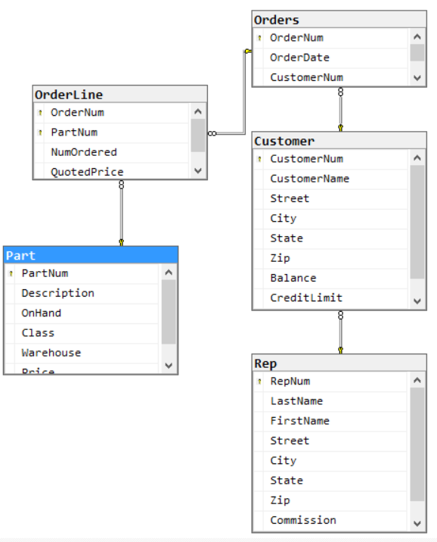

## 

## Directions

* Write the following queries
* Screenshot the **working SQL and output screen**.
* Submit to Blackboard - be sure your name is in the file

## Queries

If I do not specify a field list, use * for the field list. For each query, I have specified the number of rows you should see

1. List the customernum and customername of all customers. -- 10 rows  
   SQL

**select CustomerNum, CustomerName**

**from Customer;**  
  
OUTPUT

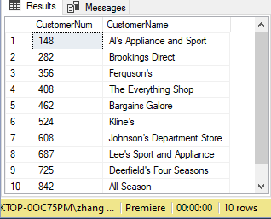

1. List the complete part table, sorted by description. -- 10 rows  
   SQL

**select * from Part**

**order by Description;**  
  
OUTPUT

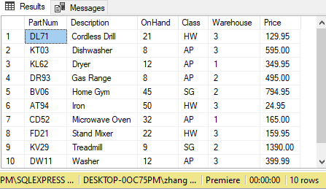

1. List the class, description, onhand, price for all parts sorted by description within class (sort by class first) -- 10 records, AP dishwasher will be first  
   SQL  
   **select Class, Description, Onhand, Price**

**from Part**

**order by Class, Description;**

OUTPUT

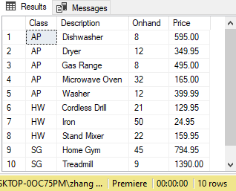

1. List the class, description, onhand, price for all parts that cost more than $400 -- 4 rows  
   SQL  
   **select Class, Description, Onhand, Price**

**from Part**

**where Price > 400;**

OUTPUT

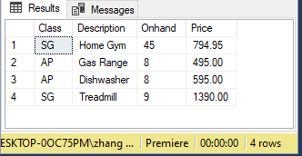

1. List the customername, customernum, repnum and creditlimit of all customers that are represented by sales rep 35 **or** have a credit limit of 10000. Sort by customerName -- 6 rows, Bargains Galore first  
   SQL  
   **select CustomerName, CustomerNum, RepNum, CreditLimit**

**from Customer**

**where RepNum = 35 or CreditLimit = 10000**

**order by CustomerName;**

OUTPUT

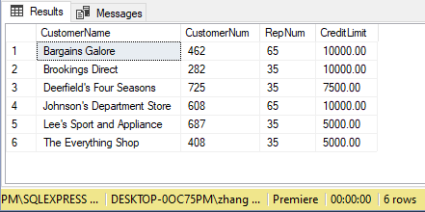

1. List the customername and customernum of all customers that are represented by sales rep 35 **and** have a credit limit of $10,000. Sort by customerName -- 1 row  
   SQL  
   **select CustomerName, CustomerNum**

**from Customer**

**where RepNum = 35 and CreditLimit = 10000**

**order by CustomerName;**

OUTPUT

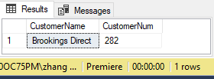

1. List the name, number, and balance of all customers represented by Juan Perez. Order by balance. Hint - list the fields in table rep and find Juan's number. Then use this in the where clause. -- 3 rows, Johnson's will be first  
   SQL  
   **select RepNum**

**from Rep**

**where FirstName = 'Juan';**

**select CustomerName, CustomerNum, Balance**

**from Customer**

**where RepNum = 65**

**order by Balance;**

OUTPUT

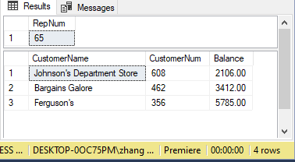

**(There are 4 rows include 1 row from other table’s result)**

1. List the all fields in the orders table that were placed on 10/20/2007. Dates are stored and queried in this format -- 2 rows  
   SQL  
   **select * from Orders**

**where OrderDate = '2007-10-20';**

OUTPUT

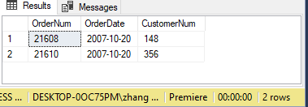

1. Display the parts that cost between 129.95 and 500. Display in **descending order** by price -- 6 rows, gas range will be first  
   SQL  
   **select * from Part**

**where Price between 129.95 and 500**

**order by price DESC;**

OUTPUT

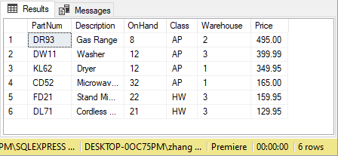

1. Display the parts that are not in the SG class. -- 8 rows  
   SQL

**select * from Part**

**where Class != 'SG';**  
  
OUTPUT

